

20603419 (ID number)

Assignment Title: Lesson Plan

Course: BA

Module: EDUC2040 Teaching & Learning Strategies

Module Convener: Dr Alberto Luis August

Declaration of No Academic Misconduct
By submitting this assignment, I agree to these statements:
- The references in the body of the text follow academic conventions and all secondary sources are acknowledged.
- The references list is complete and follows academic conventions.
- Direct quotations are either presented in quotation marks or as block quotations.
- I have proof-read the work carefully.
- I have read the university's regulations on research ethics, academic integrity, and plagiarism, and this piece of work conforms to those requirements.
- I understand that my work will be put through Turnitin text-matching software.
- I give permission for this assignment to be used for staff training purposes or for teaching purposes, provided it has been made anonymous (NB: If you do not want your assignment to be used for training or teaching purposes, please inform your programme leader).

Declaration of AI use:
If you have used any form of generative artificial intelligence (GAI) to develop your assignment, please check (x) these statements:

☒ I hereby declare that I have utilised GAI tools in the preparation of this assignment.
☒ I have used GAI solely for language checking
☐ I have used GAI for proofreading
☒ I have used GAI for the purpose of translating.
☒ I confirm that GAI tools are only used as supplementary resources to facilitate my learning, not to produce assignment content that does not truthfully reflect my understanding and efforts.
☒ The insights and suggestions provided by AI have been critically evaluated and integrated into my work, and I have maintained responsibility for the final content and analysis presented in this assignment.
☒ I have ensured that the use of AI has been in accordance with the academic integrity guidelines of my institution.
☒ I confirm that I have attached my original scripts and scripts generated by GAI, at the end of this assignment.
☐ I confirm that I HAVE NOT used GAI for this assignment.

Deductive Learning Lesson Plan

Teacher: Hiroki Uchimaru | Date: 1st December  Time/Duration: 30 minutes |  |  |  | Grade/Class/Subject:  Grade 7/ Japanese/ Language
Unit/Theme/Topic:  Introducing in Japanese |  |  |  | Content Standards/Learning Outcomes:  Students will be able to:  ・Introduce their name, age and nationality verbally.  ・Write their introducing sentences.  ・Identifying students name, age and nationality from what they said.  ・Familiarity with greetings (e.g., こんにちは、さようなら、ありがとう)
Content Objectives:  Students will be able to:  ・understand and explain the meanings and appropriate uses of basic Japanese greetings.  ・Use basic sentence in different situations. (e.g., morning, noon, after noon)  ・Form three easy introducing sentences.  ・understand the culture aspects related to Japanese greetings. (e.g., bowing and polite expressions)  ・Apply learned greeting with pair interactions. |  |  |  | Language Objectives:  Listening:  ・Students will be able to understand Basic Japanese greetings and self-introduction phrases by listening to friends  ・students will recognize name, country of origin and ages in basic spoken language.  Speaking:  ・Students will be able speak basic greetings  (e.g., Konnichiwa, Ohayou, Konbanwa)  ・Students will create a simple self-introduction using phrases  (e.g., I am 〜: watasiha 〜desu.  I am from 〜: 〜kara kimashita.  I am 〜 years old : 〜sai desu. )  Reading:  ・Students will be able to read and understand the self-introduction sentence and greeting phrases.  ・Students will identify vocabulary (name, country, age) in shorts text.  Writing:  ・Students will be able to write three basic self-introduction and greeting sentences.  ・Students will correctly write key vocabulary (e.g. name, country, age) by using romaji.
Key Vocabulary:  Greetings  ・こんにちは (Hello, Good afternoon)  ・おはよう (Good morning)  ・こんばんは (Good evening)  ・さようなら (Goodbye)  ・はじめました (Nice to meet you)  ・ありがとう/ありがとうございます (Thank you)  Self-introduction  ・わたしは〜です。(I am …)  ・〜からきました。(I’m from …)  ・〜さいです。(I am … years old)  ・なまえ (name)  ・くに (country)  ・とし (age)  ・がっこう (school)  Basic phrases  ・Number until 20 in Japanese  ・なまえは？ (What’s your name?)  ・どこからきました？ (Where are you from?)  ・いくつですか？ (How old are you?)  ・〜がすきですか？ (Do you like …?) |  |  | Supplementary Materials:  ・Visual materials  Presentation slides for students to look during class and after class.  ・Work sheet  This work sheet is not to evaluate students, this is to take note for students and remember by using their hand to write.
Previous Knowledge
- Understanding of simple sentence structures
- Know about the culture and the rules (e.g., bowing, polite)
- Students know the rules of the classroom, and know when to sit quietly and listen to the teacher’s instruction.
- Students are familiar to the Japanese (characteristics: Hiragana and katakana)

Content/Concepts
- Content:
basic greetings and introducing sentences.
Name, country, ages and some words that they are interest.

- Concepts:
Use greetings appropriately depending on the situation.
Self-instructions have to be words or sentences that convey information about oneself to others.
Language expressions have both of meaning and the usage depending on content.

SIOP FEATURES
PREPARATION |  | SCAFFOLDING |  |  |  | GROUP OPTIONS
Adaptation of Content |  | Modelling |  |  |  | Whole Class
Links to Background |  | Guided Practice |  |  |  | Small Groups
Strategies Incorporated |  | Independent Practice |  |  |  | Partners
 |  | Comprehensible Input |  |  |  | Independent
INTEGRATION OF PROCESSES |  | APPLICATION |  |  |  | ASSESSMENT
Listening |  | Hands-on |  |  |  | Individual
Speaking |  | Meaningful |  |  |  | Group
Reading |  | Linked to Objectives |  |  |  | Written
Writing |  | Promotes Engagement |  |  |  | Oral
Sequence of Lesson
Introduction: 3 minutes
In this introduction, teacher greet with energy first and make a good mood classroom which is energetic and students are free to speak out when teacher ask questions.
After greeting teacher introduce the topic of today’s class (Learning basic Japanese phrases), and start first small activity which is showing 3 pictures related to Japan and ask students to answer “Do you know this?”

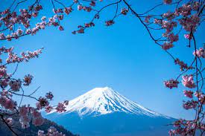
[Figure 1]. (Mt. Fuji, Sushi, Naoya Inoue: most famous Japanese boxer. Picture from google.)
- Presentation used in class are already projected (First pages) -
Teacher- Good morning everyone!! (Greet with energy)
If students are not responding enough, ask again.
Teacher- Today we are going to learn about introducing and greeting phrases in Japanese.
- Show three picture - (Figure 1)
Teacher- These pictures are related to Japan? Does anyone know what is it?
If there are students who are raising their hand priorities them rather them students who speak out. By saying like, I heard some of the answer but let me ask student 1 who are raising hand.

Correct answer: That’s correct. Good job!! (Parise them with positive reinforcement).
Wrong answer: Ohh close nice guess though. (Do not make students embarrass because this might demotivate students)

- After three picture –
Let’s move on to main learning for today.

Development: 15 minutes
Step 1: Explanation part (10 minutes)
In this explanation part, teacher are require to conduct lesson that students can observable and verbally learn. This explanation include basic Japanese self-introduction sentences and greeting phrases.
Teacher- Look at this slides, these are the self-introduction sentences with Japanese characteristic, romaji (for students to read) and English translation.

1, 私は です。 (watashi wa desu。: I am name.)
2, さいです。 ( sai desu。: I am age years old.)
3, からきました。( kara kimashita。: I am from nationality.)

- Teacher read one by one by putting example words and led students repeat -

After students repeats self-introduction sentences. Teacher hand out the paper with fill the blank and make your own self-introduction (Figure 2).

In this paper students are able to use English and number, also when they are speaking, they can use English and number as well. If there are students who wants to know how to say it in Japanese help them.

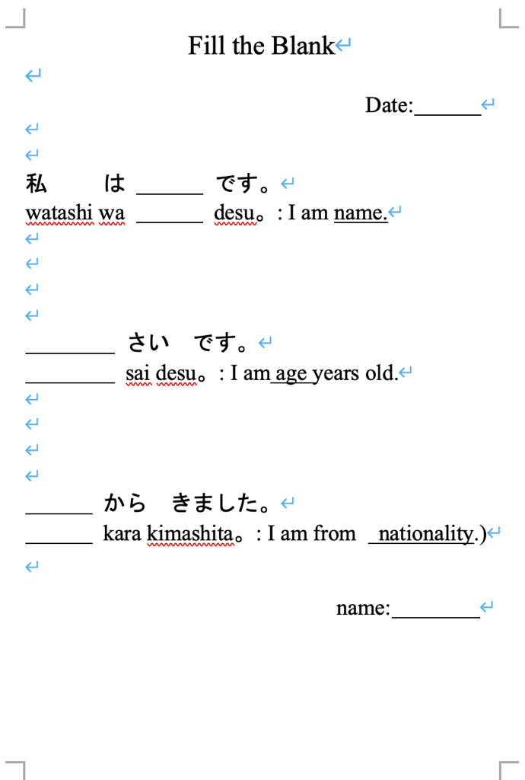
[Figure 2]. (Own self-introduction. Created by Hiroki.)

After one or two minutes move on to the next greeting phrases.

Teacher shows the slides with Japanese characteristic, romaji (for students to read) and English translation.

1, おはよう (ohayou。： Good morning.)
2, こんにちは (konnichiwa。： Hello. Used from AM11:00 – PM17:00 or 18:00)
3, こんばんは (konbanwa。: Hello. Used from PM18:00 - midnight)
4, さよなら (sayounara。： Good bye.)
5, よろしくおねがいします (yorosiku onegaishimasu。： Nice to meet you.)

Teacher read it one by one and students repeat it. During this practice teacher is going to bow and greet. Because this is related to Japanese culture.

After explaining greeting, move on to next activity.

Step 2: Practical activity (5 minutes)
In pair students are going to practice their self-introduction. Students are not able to do conversation by using Japanese so, practice will be one students ask the name and next students tell the name. Age and nationality are organized same.

At this activity, it is more focus on students can able to speak Japanese not perfect grammar. Due to this, sentence structure is not well organize but this is for students to use their voice and learn and remember how to pronounce Japanese.

Teacher- Please get in the pair. And Practice self-introduction with your friends. First students tell the name and after that next students tell the name. Same things for the ages and nationality.
Teacher- Also its okay to put greetings in front of the self-introduction sentence.
- Show how to do it -
Teacher- Konnichiwa。Watashi wa desu。(Hello. I’m .)

While students are practicing teacher walk around and listen to students practice. And if they are doing well praise them. If they are facing difficulty or want to know Japanese words help them and practice together for a little bit.

Closure: (2 minutes)
Review today’s self-introduction sentence and greetings in a quiz format. Quiz will be asking questions like, “How do you greet at night?” or “How to say good morning?”
Praise the student who answer.
At the end of class, whole class say “sayounara!” together to end the lesson.

Teacher- Let’s revice what we learn today.
Teacher- “How do you greet at night?”
Teacher- “How to say good morning?”

Conclusion: (10 minutes)
Pair dialogue recording. This will be 5% of final results.
Students get in to pair and record according to this dialogue. This dialogue will be provided with a paper so students can write their own name, ages and nationality to make it easy to go through.

In this assessment, students are requiring to pronounce 60% accuracy.
- Ways to determine accuracy -
There are 3 levels
Level 1: Students pronounce most of words wrong (40% accuracy)
Level 2: Students pronounce wrong 10 times. (50% accuracy)
Level 3: Students pronounce wrong 5 times. (60% accuracy)

Teacher- Let’s do final activity. Please record dialogue with your pair according to dialogue. This will be graded 5 % of the final results. So please submit it.
- After 10 minutes -
Teacher- Its seems like almost end of the class.
Teacher- Okay everyone did really well today. Let’s say sayounara together to end the class for today.
Teacher and students- Sayounara. (End of the class)

Dialogue will be: (Figure 3)
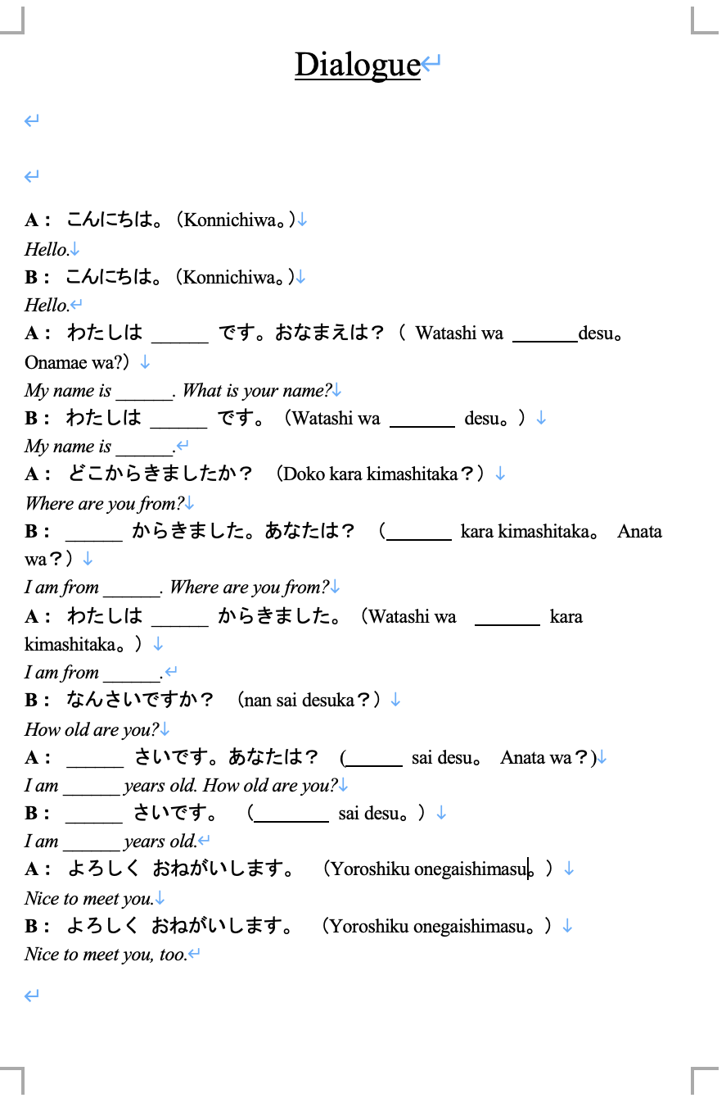
[Figure 3]. (Conclusion pair recording activity. Created by Hiroki.)

Slide used in class
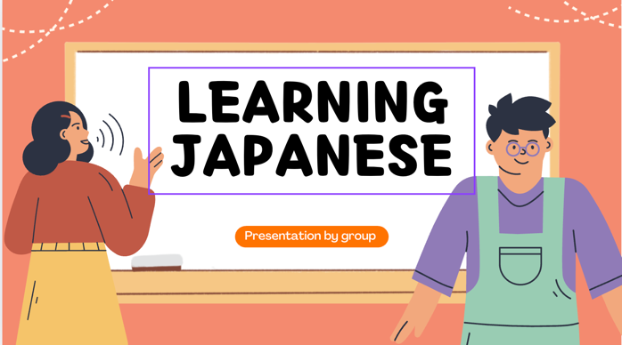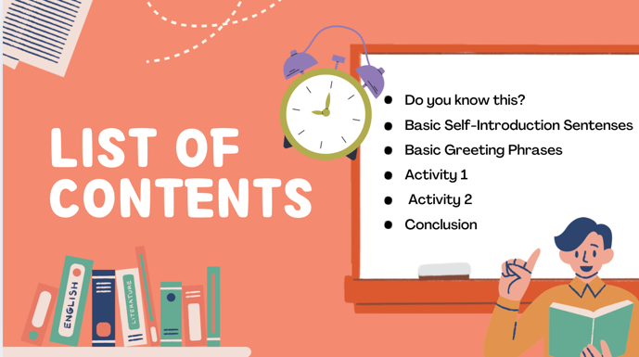
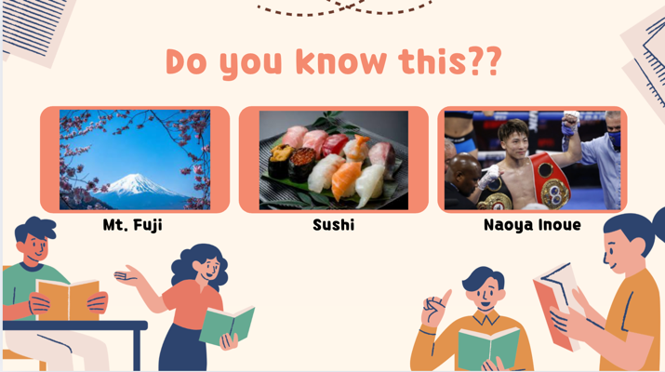(Cover the name for students to enjoy answering)
Slides for introduction.

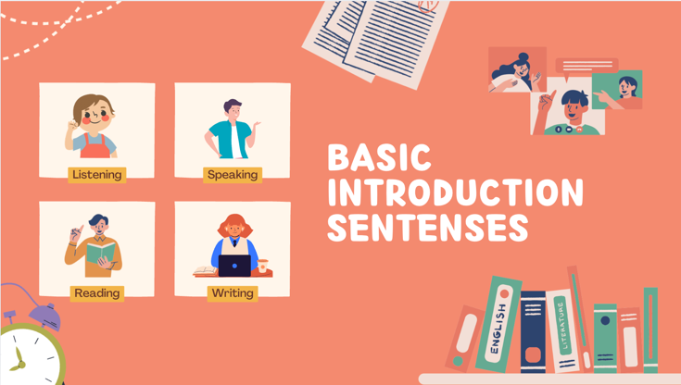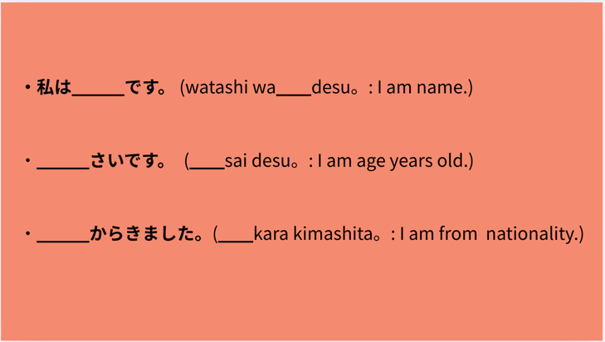
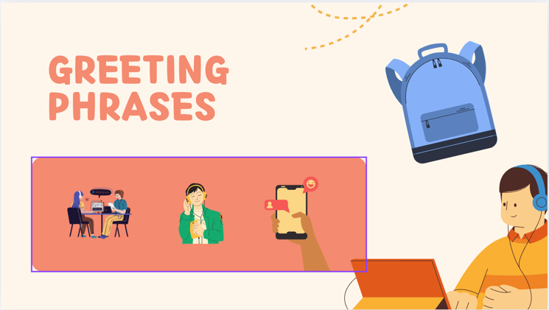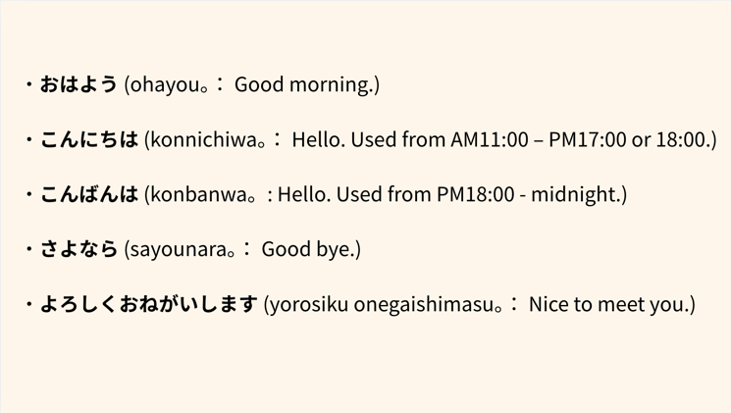
Slides for explanation parts.

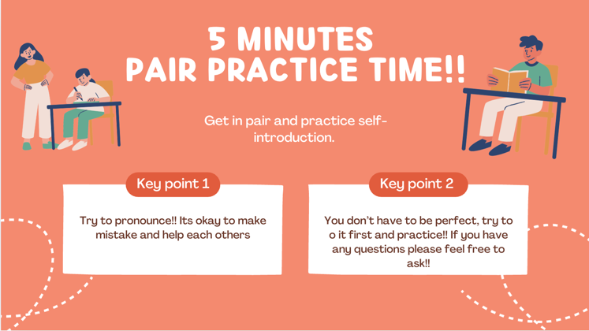
Slide for practical activity.

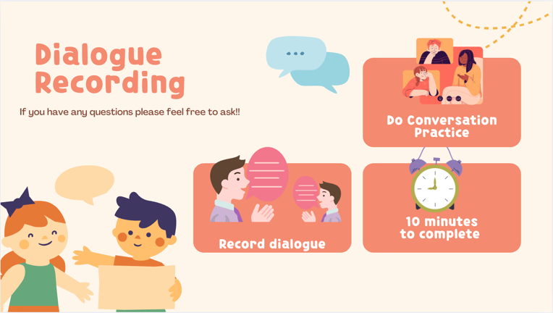
Slides for Conclusion activity.

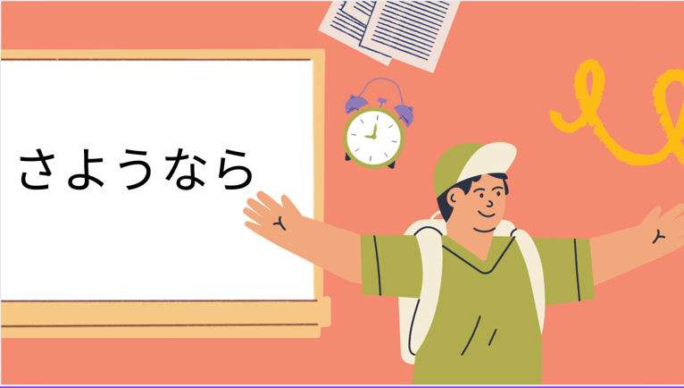
Final slides.

Theory and strategy used in class
Vygotsky theory
In this class, there are pair activity. According to (Vygotsky, 1978), ZPD’s working with other it can be a help for pairs to gain and learn more. For example, practicing pronunciation, students are able to check each other and teach were is wrong.

Positive reinforcement
In this class, students are requiring to answer few questions, due to this when students get right answer teacher need to praise students. (Kurnia et al., 2024)
According to (Kurnia et al., 2024), it will affect students’ participation to the class and also well-being. Therefore, using positive reinforcement is significant strategy for teacher to use to make students motivated and more energetic to answer in the class. However, this can be accomplished when the classrooms’ environments are comfortable for students to speak out.

Multimodal teaching
In this class, teacher will use pictures (introduction activity), teacher gesture (bowing), listening to pair, dialogue practice, presentation slides (use in class), and pronunciation (correct pronunciation from teacher).
According to (Kindi and AI- Jarf, 2024), combining text and visuals support will make students learning more efficiently and improve the memory. Due to this, this class need to use not only presentation slides and teachers’ explanation but also, more visual images or audio.

Student-centered and Teacher-centered
In this lesson, first introduction have to be Teacher-centered to navigate and attracting students in to the class. And also, explanation parts have to be Student-centered. This is to teach students language and give them knowledge, so this parts have to be Teacher-centered. But lesson goes and activity starts classroom will be more Student-centered. Because a lot activities are students based and teacher is there for help.
Therefore, this lesson plan used both teacher and Student-centered.

Reflection

References:

Kindi, A., & Al-Jarf, R. (2024). Journal of english language teaching and applied linguistics multimodal teaching and learning in the EFL college classroom.

Kurnia, T., Rahmani, H., & Magister. (2024). The role of positive reinforcement on students in english language learning: A skinnerian behaviorist. JOEY, 3(1), 1–5. https://doi.org/10.35316/JOEY.2022.vxix.x-xx

Vygotsky, L. (1978). Mind in society: The development of higher psychological processes. Harvard University Press.

AI declaration proof


